Project Design Phase
Solution Architecture

Date | 15 February 2026
Team ID | LTVIP2026TMIDS61809
Project Name | Toy Craft Tales: Tableau's Vision into Toy Manufacturer Data
Maximum Marks | 4Marks

Solution Architecture:
Solution architecture is a complex process–with many sub-processes– that bridges the gap between business problems and technology solutions. Its goals are to:

- Find the best techsolution to solve existing business problems.
- Describe the structure, characteristics, behavior, and other aspects of the software to project stakeholders.
- Define features, development phases, and solution requirements.
- Provide specifications according to which the solution is defined, managed, and delivered.

Example-Solution Architecture Diagram:

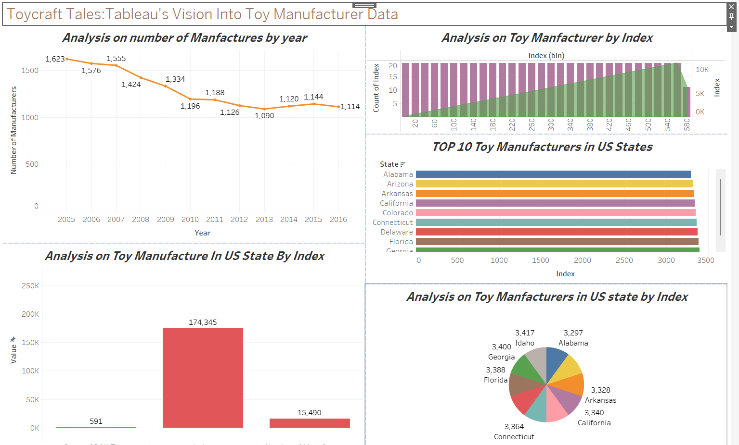
Figure1:ArchitectureanddataflowoftheToyCraftTales
Reference:https://aws.amazon.com/blogs/industries/voice-applications-in-clinical-researchpowered-by-ai-on-aws-part-1-architecture-and-design-considerations/

